**Rapid Benefit Indicator (RBI) Spatial Analysis Toolset Manual**

Authors: 1 Justin Bousquin, 2 Marisa Mazzotta, 2 Walter Berry

1: U.S. EPA, Office of Research and Development, National Health and Environmental Effects Laboratory, Gulf Ecology Division, Gulf Breeze, FL 32561

2: U.S. EPA, Office of Research and Development, National Health and Environmental Effects Laboratory, Atlantic Ecology Division, Narragansett, RI 02882

**Disclaimer:**

This project was supported in part by appointments to the Oak Ridge Institute for Science and Education participant research program supported by an interagency agreement between the U.S. Environmental Protection Agency and the U.S. Department of Energy. This document has been reviewed by the U.S. Environmental Protection Agency, Office of Research and Development, and approved for publication. Any mention of trade names, products, or services does not imply an endorsement by the U.S. Government or the U.S. Environmental Protection Agency. The EPA does not endorse any commercial products, services, or enterprises. This is part of contribution number ORD-018240 of the Atlantic Ecology Division, National Health and Environmental Effects Laboratory, Office of Research and Development, U.S. Environmental Protection Agency.

**Overview:**

The Rapid Benefits Indicators (RBI) approach consists of five steps and is outlined in **Assessing the Benefits of Wetland Restoration – A Rapid Benefits Indicators Approach for Decision Makers**,

<https://cfpub.epa.gov/si/si_public_record_Report.cfm?dirEntryId=325010>

hereafter referred to as the “guide”. This spatial analysis tool is intended to be used to analyze existing spatial information to get metrics for many of the indicators developed in that guide. This manual gives you directions on the mechanics of the tool and its data requirements, but does not detail the reasoning behind the indicators and how to use results of the assessment as the guide does.

**Requirements:**

The Rapid Benefits Indicators (RBI) spatial analysis toolset is an arcGIS python toolbox. This means that it can be used within ESRI’s desktop software versions 10.1 or newer. The toolbox is not yet compatible with arcGIS Pro, and has only been tested on desktop versions 10.1, 10.2, 10.3 and 10.4. Operating system and hardware requirements for running this tool are the same as those for using arcGIS desktop:

<http://desktop.arcgis.com/en/arcmap/10.3/get-started/system-requirements/arcgis-engine-system-requirements.htm>

**Downloading Tool:**

The python toolbox (.pyt extension) and associated files required to perform the spatial analysis can be downloaded as a package or as individual files:

Recommended: If downloading from github go to the repository <https://github.com/USEPA/Rapid-Benefit-Indicators-Tools> and click the green “Clone or download” button, when the drop down window opens “Download Zip” will download all the associated files as a compressed zip file. Unzip the file to your desired file location.

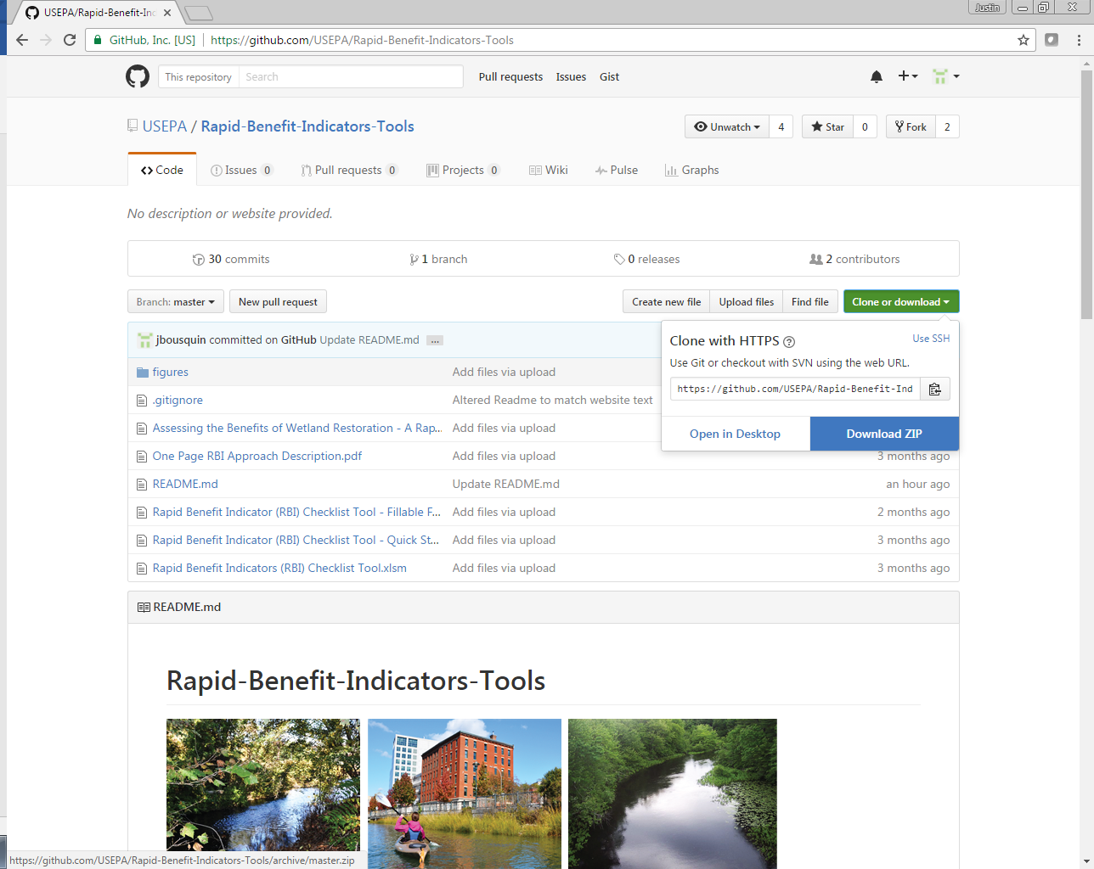

Depending on the requirements of your analysis, you may wish to download individual files rather than all associated files. To download the python toolbox by itself click the “Rapid Benefit Indicator (RBI) Spatial Analysis Toolbox” link within the py_spatial directory. This shows the code used in the tool. To download, click the “Raw” button, then right click and select “Save as…”. This will bring up the familiar Save As window where you can navigate to the location you want the file saved. You can rename the file, but be sure that it ends in the .pyt extension, not .txt. Be sure to save associated files (see Associated Files section) in the same directory as the tool for full functionality.

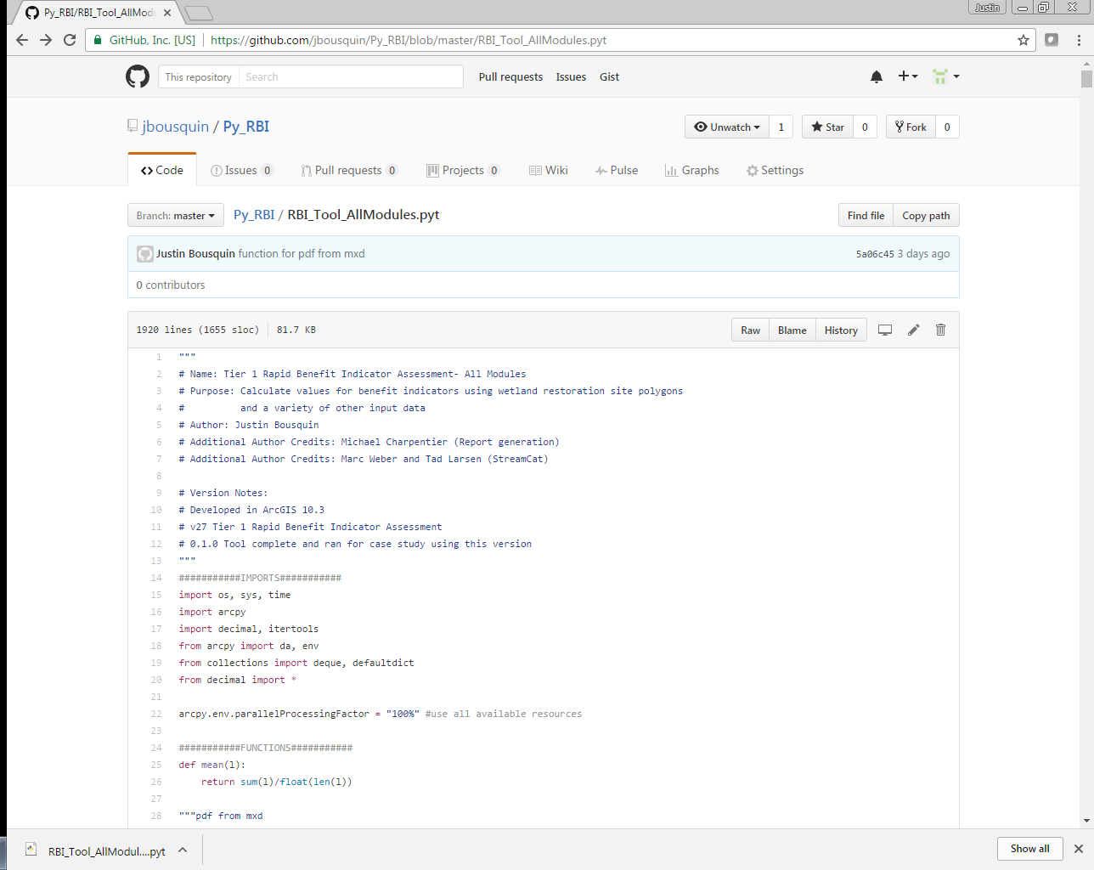

**Installing Tool:**

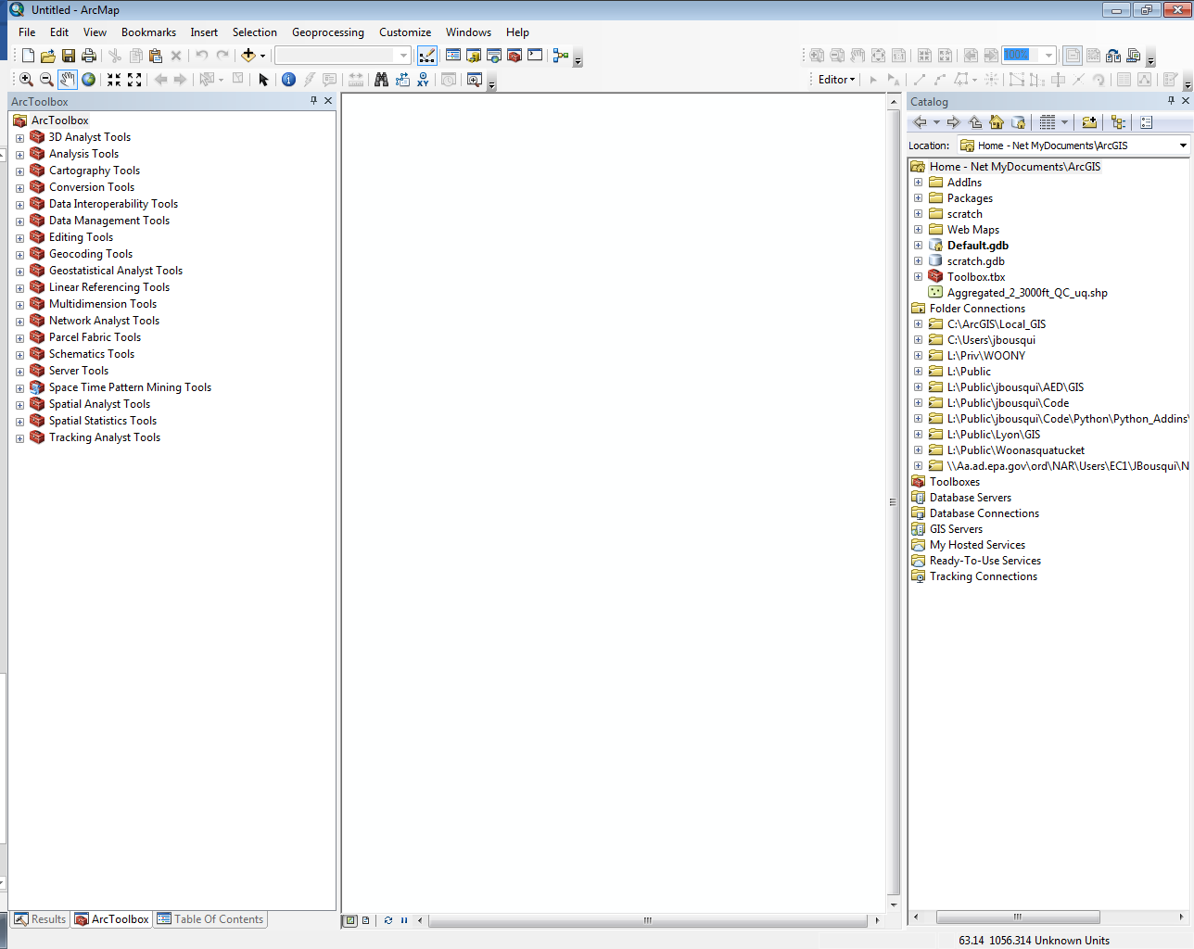Python Toolboxes are easy to install into arcMap or arcCatalog and operate just like other geoprocessing tools. If it isn’t already open, open the arcToolbox window by clicking the “Geoprocessing” button on the top ribbon and then arcToolbox from the drop down.

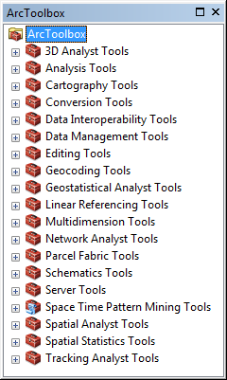

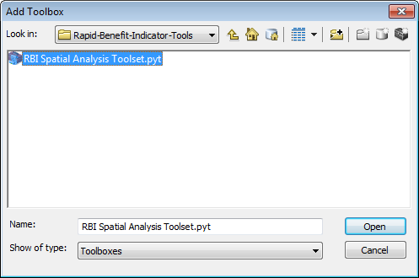 In the ArcToolbox window (A) right click and select “Add Toolbox…” then in the Add Toolbox window (B) navigate to the py_Spatial folder and select the “RBI Spatial Analysis Toolset” you just downloaded.

**B**

**A**

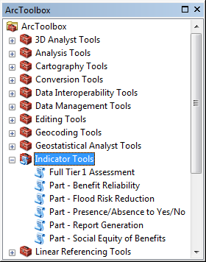

**C**

Once the toolbox is added it will appear in the ArcToolbox window (C) alongside other toolboxes, and individual tools within the toolbox can be selected just like other toolboxes.

**Associated Files:**

In addition to the python toolbox, there are also several other files that get downloaded and help to streamline your analysis.

.xml files – five files, each named after the tool they refer to, provide additional tool help when using each of the tools within the RBI Spatial Analysis Toolset. Without the .xml files the tool will have descriptive help text for the tool in general but will not have the full Tool Help and descriptive help for each tool parameter. These files do not impact tool functionality.

NHD+ files – two files are available for download with the tool, a table with catchments (Catchment.shp) and a table with the upstream/downstream relationships (PlusFlow.dbf). The full tool is designed to find these files in the same folder as the tool itself. In the “Part – Flood Risk Reduction” tool you can specify the files to use for catchments and their upstream/downstream relationships. This is useful if you wish to use your own catchments or NHD+ files updated from the version 2 available with the tool:

<http://www.horizon-systems.com/NHDPlus/NHDPlusV2_data.php>

.mxd file – a map file is available for download with the tool that includes all the layout formatting required to produce pdf results reports. The full tool is designed to automatically find these files in the same folder as the tool itself. In the “Part – Report Generation” tool you can specify the mapfile (.mxd) you want to use for formatting if you wish to move the file.

**Using the toolset:**

There are two ways to use the toolset to run your spatial analysis, either by using the individual “Part” tools in a stepwise process along with parts of the “Full Tier I Assessment” tool or by loading all of the data into the “Full Tier I Assessment” tool and running it once. Data requirements for each benefit you may choose to assess are described in the **Data Requirements** section. Then a description of the full tool is provided, followed by sections on each of the Part tools and how they differ from the Full Tier 1 Assessment tool.

**Data Requirements:**

**Restoration Site Polygons** - Running analysis for any benefit requires polygons representing the area of the restoration sites being assessed. All other input datasets will be re-projected based on the projection used for the restoration sites to ensure distortion and mis-alignments are minimized. All fields and spatial data in this feature layer will be copied from the sites to the output table, allowing the output table from one partial analysis to be used as an input (Restoration Site Polygons) to the next.

**Output –** A file name and location must be specified for the dataset that results from the analysis. It is recommended that users create a new personal geodatabase and save their output there because the folder location of the output file is also used to save intermediate files. If files with the same names as the intermediates already exist in the specified file they will be deleted and overwritten.

**Address Points** or **Population Raster** - Most benefits require a dataset representing people in the area around the restoration sites that could potentially receive benefits from site restoration. The spatial range where people should be considered varies depending on the benefits chosen for assessment, but a buffer of 12 miles around the site will usually be enough. The tool will accept either points representing individual homes or a grid format (raster) representation of population. Where points are not available we recommend using the EnviroAtlas - Dasymetric Population available for the conterminous United States:

<https://catalog.data.gov/dataset/enviroatlas-dasymetric-population-for-the-conterminous-united-states>

The spatial analysis tool is designed to assess up to Five (5) benefits that were developed for urban wetland restoration sites, each having their own specific data requirements:

**Reduced Flood Risk** – Flood risk reduction benefits flow from where they are produced to downstream areas that would otherwise flood. Flood risk reduction indicator metrics include the number of beneficiaries in areas that flood downstream of the site. The“NHD+ Catchments” dataset is used to determine what catchments are within 2.5 miles of the site. The tool selects the catchment(s) in the “NHD+ Catchments” dataset that overlap the site, and makes a sub-selection of the catchments in 2.5 miles based on which catchments are downstream from those that overlap the site. Downstream catchments are identified using the “NHD Join Field“ field from the “NHD+ Catchments” dataset that matches the To/From COMID field in the “Relationship Table” dataset. Once a catchment falls completely outside of 2.5 miles of the site no further downstream catchments are included even if the stream network flows back into 2.5 miles of the site. However, since the stream network may curve and loop around within 2.5 miles of the site, the length of the stream network included will typically exceed 2.5 miles. The “Flood Zone” dataset is used to define the area that floods, and gets clipped by the resulting catchments to determine where people may benefit downstream of the site. “Dams and Levees” and “Wetlands” are features that may act as substitutes, reducing flow risk. All substitute features in range are counted, regardless of being upstream or downstream.

|  |  |  |  |
| --- | --- | --- | --- |
| **Parameter** | **Explanation** | **Data Type** | **Suggested Source** |
| Flood Zone (Polygon) | Dataset that defines flood zones (e.g. 100-yr or 500-yr) where flooding occurs | Feature Layer | FEMA, NOAA |
| Wetlands (Polygon) | Dataset that defines existing wetlands | Feature Layer | NWI |
| Dams and Levees | Point, line or polygon dataset that defines other flood prevention infrastructure such as dams and levees | Feature Layer | USGS NHD+ |
| NHD+ Catchments | Dataset that defines catchments around the restoration sites | Feature Layer | Available with tool  (Catchment.shp) |
| NHD Join Field | Field that holds the ID associated with the catchment in the relationship table | Field | Available with tool  (FEATUREID) |
| Relationship Table | Table with to/from COMID fields that corresponding to the NHD Join Field and indicate upstream/downstream catchments | Table | Available with tool  (PlusFlow.dbf) |

**Scenic Views –** Scenic view benefits flow from aesthetically pleasing landscapes outward to surrounding areas. Residents in the surrounding area and people moving through, assessed using “Trails” and “Roads” route datasets, may receive benefits. The existing “Wetlands” features are considered substitutes that may already benefit people. However, other types of greenspace, the “Landuse or Greenspace” dataset, are complements where greater landscape variety increases view value. The user has the flexibility to choose what field and values represent value adding greenspace in the landuse dataset.

|  |  |  |  |
| --- | --- | --- | --- |
| **Parameter** | **Explanation** | **Data Type** | **Suggested Source** |
| Trails (hiking, biking, etc.) | Point, line or polygon dataset that defines other places people may receive benefits | Feature Layer | NPS, State agency, NGOs |
| Roads (streets highways, etc.) | Point, line or polygon dataset that defines other places people may receive benefits | Feature Layer | Tiger, ESRI, Google, E911 |
| Wetlands (Polygon) | Dataset that defines existing wetlands | Feature Layer | NWI |
| Landuse or Greenspace (Polygon) | Dataset that defines alternative greenspace that may | Feature Layer | NLCD |
| Greenspace Field | Field that differentiates greenspace from other landuse | Field | user specified |
| Greenspace Field Values | Values in the field which are greenspace | Values | user specified |

**Environmental Education –** Environmental education benefits are the only ones that can be assessed without a population dataset (addresses or population raster). The “Educational Institutions” dataset is used instead and can include public schools as well as early education institutions like pre-k or daycare. The existing “Wetlands” features are considered substitutes that may already benefit people.

|  |  |  |  |
| --- | --- | --- | --- |
| **Parameter** | **Explanation** | **Data Type** | **Suggested Source** |
| Educational Institutions | Point dataset that defines education institutions that may receive benefits | Feature Layer | State department of education |
| Wetlands (Polygon) | Dataset that defines existing wetlands | Feature Layer | NWI |

**Recreation –** Recreation benefits require people to travel to the site where recreation opportunities are to benefit. People in walking or driving distance of the site are assumed to be able to benefit. The presence of “Trails” or “Bus Stops” dataset features also increase who could benefit by making the site accessible by alternative modes of transportation. The existing “Wetlands” features are considered substitutes that may already benefit people. However, other types of green or open space adjacent to the restoration site are complements, as these may increase the types of recreational opportunities available.

|  |  |  |  |
| --- | --- | --- | --- |
| **Parameter** | **Explanation** | **Data Type** | **Suggested Source** |
| Trails (hiking, biking, etc.) | Point, line or polygon dataset that defines trails that help people access benefits | Feature Layer | NPS, State agencies, NGOs |
| Bus Stops | Point, line or polygon dataset that defines bus stops that help people access benefits | Feature Layer | State department of transportation |
| Wetlands (Polygon) | Dataset that defines existing wetlands | Feature Layer | NWI |
| Landuse or Greenspace (Polygon) | Dataset that defines alternative greenspace that may add value | Feature Layer | NLCD |
| Greenspace Field | Field that differentiates greenspace from other landuse | Field | user specified |
| Greenspace Field Values | Values in the field which are greenspace | Values | user specified |

**Bird Watching** – Bird watching benefits flow from where the bird is outward to surrounding areas where people can see them. Bird Watching benefits can be received in the surrounding area by residents or people moving through on trails or roads (“Trails” and “Roads” datasets).

|  |  |  |  |
| --- | --- | --- | --- |
| **Parameter** | **Explanation** | **Data Type** | **Suggested Source** |
| Trails (hiking, biking, etc.) | Point, line or polygon dataset that defines other places people may receive benefits | Feature Layer | NPS, State departments, NGOs |
| Roads (streets highways, etc.) | Point, line or polygon dataset that defines other places people may receive benefits | Feature Layer | Tiger, ESRI, Google, E911 |

In addition to the optional benefits that can be assessed, the restoration site can also be assessed for its potential to deliver benefits in a socially equitable way and reliably into the future.

**Social Equity** – The social equity of restoration sites can be compared for each benefit based on who is expected to benefit, but these will typically be similar across different benefits so it is recommended that users run social equity once for each site.

|  |  |  |  |
| --- | --- | --- | --- |
| **Parameter** | **Explanation** | **Data Type** | **Suggested Source** |
| SoVI | Dataset that defines the social vulnerability of different areas | Feature Layer | NOAA |
| Vulnerable Field | Field designating population vulnerability | Field |  |
| Vulnerable Values | Values in the field which are vulnerable | Values |  |
| Buffer Distance | Value and units | Distance |  |

**Reliability –** Restoration sites that will persist further into the future are higher priority that an equal site that is not expected to persist into the future.

|  |  |  |  |
| --- | --- | --- | --- |
| **Parameter** | **Explanation** | **Data Type** | **Suggested Source** |
| Conservation Lands | Dataset that defines areas that may be conserved or otherwise protected against future threats and development | Feature Layer | State Planning |
| Conservation Field | Field designating protected areas | Field |  |
| Conservation Types | Values in the field which are protected | Values |  |
| Buffer Distance | Value and units | Distance |  |

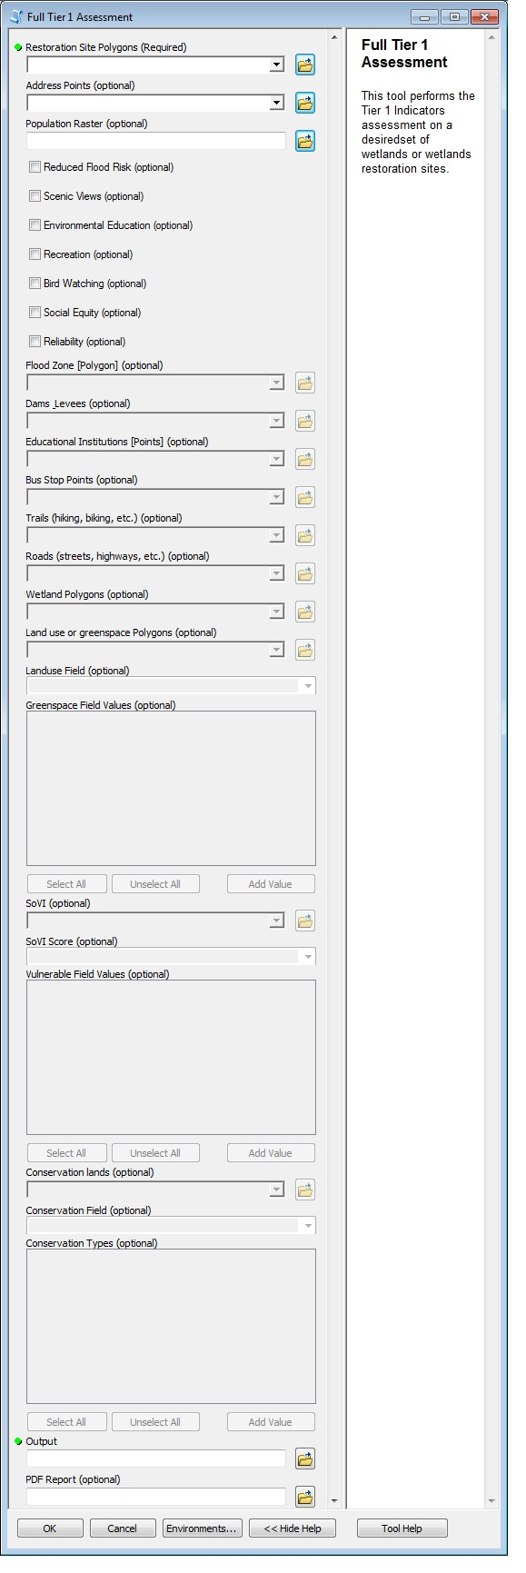**Full Tier 1 Assessment:**

1

8

Many of the steps of the RBI spatial analysis process require the same dataset inputs. The Full Tier 1 Assessment tool allows a user to input these datasets once and reuse them for multiple benefits/steps. See the “Data Requirements” manual section for details on all of the datasets used to run the RBI Spatial Analysis Tools and which benefit uses each.

4

2

Datasets are added either by dragging and dropping a layer into the fillable space or by navigating the tool to the dataset using the corresponding open icon to the right.

5

(1) **Restoration Site Polygons**, (2) **Address Points** or **Population Raster**, and the (3) **Output** file must always be specified for the tool to run. Either Address Points or the Population Raster are needed to run the analysis, and once entered the other will become gray and non-fillable.

Check boxes are clicked to select which benefits will be assessed (4: Reduced Flood Risk, Scenic Views, Environmental Education, Bird Watching, Recreation) and if additional site metrics (5: Social Equity, Reliability) will be calculated. As these boxes are checked, the datasets required for each will go from being gray to being fillable. This feature of the tool helps to make it clearer what the data requirements of your desired analysis are. If left blank the tool will run but will skip some calculating metrics.

7

6

Flood Zone, Dams Levees, Educational Institutions, Bus Stops, Trails, Roads, Wetlands, Landuse, SoVI, and Conservation Lands are all spatial datasets that can be a geodatabase feature class, a shapefile, or a feature layer with a selection.

The Landuse, SoVI and Conservation Lands datasets each require certain values in certain fields to be specified. This increases flexibility and limits pre-processing. For example, in Landuse the tool only uses greenspace classified features. The classification (6) **Field** within your landuse dataset and its selected greenspace (7) **Values** are user specified, allowing for different datasets and greenspace definitions.

In addition to the output table, the tool can also create a pdf report when a new PDF Report file name is entered.

9

All tools have (8) Help guidance and a (9) Tool Help sheet when downloaded as part of the tool package.

3

**Indicator 🡪 Results Table Fields**

|  |  |  |  |
| --- | --- | --- | --- |
| **Benefit** | **Indicator** | **Text** | **Field Name** |
| Flood Risk | How Many Benefit? | 2.5 mi downstream of site and in flood zone | FR_2_cnt |
| Flood Risk | Service Quality | Area of restoration site (acres) | FR_3A_acr |
| Flood Risk | Service Quality | Features that increase retention volume? | FR_3A_boo |
| Flood Risk | Scarcity | Dams and levees 2.5 mi downstream? | FR_3B_boo |
| Flood Risk | Scarcity | Wetlands within 5 mi (number or % area) | FR_3B_sca |
| Flood Risk | Preferences | Are people worried about flood risk? | FR_3D_boo |
| Scenic Views | How Many Benefit? | Number within 160 ft of site | V_2_50 |
| Scenic Views | How Many Benefit? | Number within 160-325 ft of site | V_2_100 |
| Scenic Views | How Many Benefit? | Weighted number who benefit (70/30) | V_2_score |
| Scenic Views | How Many Benefit? | Are there roads or trails within 325 ft of site? | V_2_boo |
| Scenic Views | Service Quality | Aesthetic features or characteristics? | V_3A_boo |
| Scenic Views | Scarcity | Wetlands or water within 650 ft (number or %) | V_3B_scar |
| Scenic Views | Complements | Natural land use types within 650 ft (types) | V_3C_comp |
| Scenic Views | Preferences | Will people find it aesthetically pleasing? | V_3D_boo |
| Environmental Education | How Many Benefit? | Educational institutions within 0.25 mi of site | EE_2_cnt |
| Environmental Education | Service Quality | Features/habitat/wildlife of educational interest? | EE_3A_boo |
| Environmental Education | Scarcity | Wetlands within 0.5 mi of the site | EE_3B_sca |
| Environmental Education | Complements | Educational facilities or infrastructure on site? | EE_3C_boo |
| Environmental Education | Preferences | Will people prefer characteristics of the site? | EE_3D_boo |
| Recreation | How Many Benefit? | Number within 1/3 mi of the site | R_2_03 |
| Recreation | How Many Benefit? | Are there bike paths within 1/3 mi of site? | R_2_03_bo |
| Recreation | How Many Benefit? | Are there bus stops within 1/3 mi of site? | R_2_03_b2 |
| Recreation | How Many Benefit? | Number within 0 to 0.5 mi of site | R_2_05 |
| Recreation | How Many Benefit? | Number within 0.5 to 6 mi of site | R_2_6 |
| Recreation | Service Quality | Total area of green space around site | R_3A_acr |
| Recreation | Scarcity | Green space within 2/3 mi of site | R_3B_sc06 |
| Recreation | Scarcity | Green space within 1 mi of site | R_3B_sc1 |
| Recreation | Scarcity | Green space within 12 mi of site | R_3B_sc12 |
| Recreation | Complements | Infrastructure supporting recreational activities? | R_3C_boo |
| Recreation | Preferences | Are there additional features on the site? | R_3D_boo |
| Bird Watching | How Many Benefit? | Number within 0.2 mi of site | B_2_cnt |
| Bird Watching | How Many Benefit? | Are there roads or trails within 0.2 mi of site? | B_2_boo |
| Bird Watching | Service Quality | Will the site support rare or unique species? | B_3A_boo |
| Bird Watching | Complements | Supporting infrastructure or habitat on site? | B_3C_boo |
| Bird Watching | Preferences | Will people be interested in birds at the site? | B_3D_boo |
| Social Equity | Percent area of buffer with selected vulnerable field value | | High |
| Reliability | Percent area of buffer with selected conserved field value | | Conserved |

**Extra Results Table Fields**

|  |  |
| --- | --- |
| **Field Name** | **Description** |
| FR_zPct | Percent area around site that is flood zone |
| FR_zDown | Area of downstream flood zone |
| FR_zDoPct | Percent flood zone in area which is downstream |
| FR_sub | Count of substitute features in FR_3B_boo |
| “SOVI values” | A field is created for each unique value that isn’t selected as vulnerable |
| Threatened | Features in the conservation layer that aren’t selected as “conserved” |

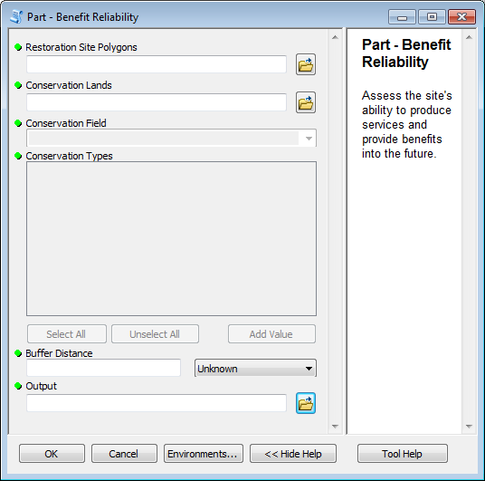**Part - Benefit Reliability**

The Benefit Reliability tool calculates the reliability of site benefits in the same way as the Full Tier 1 Assessment Tool, but the user is able to designate their own buffer distance around the restoration site that will be considered to determine the reliability instead of the default 500 ft used in the Full Tier 1 Assessment.

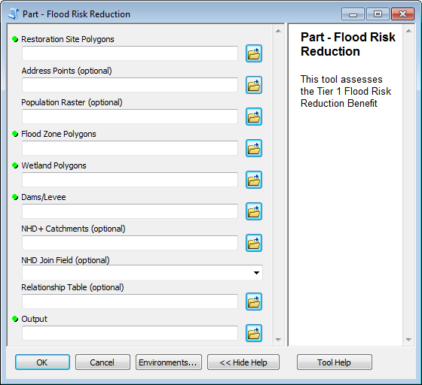

**Part – Flood Risk Reduction**

The Flood Risk Reduction tool calculates indicator metrics for flood risk reduction benefits in the same way as the Full Tier 1 Assessment Tool, but the user is able to specify the catchments to use and the field in that dataset that corresponds to the COMID for the same catchment in the specified relationship table. Whereas the Full Tier 1 Assessment assumes the NHD+ dataset was downloaded and saved with the tool package, this partial assessment tool lets a user specify their own catchments.

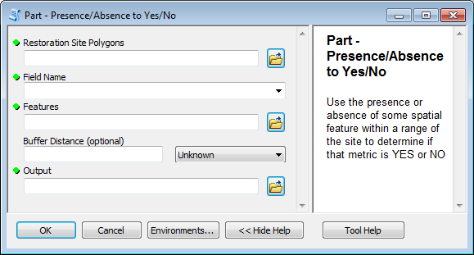

**Part – Presence/Absence to Yes/No**

The Full Tier 1 Assessment tool uses the same functionality as the Presence/Absence to Yes/No tool, but that functionality is not accessible directly. For example, for recreation benefits, this functionality is used to determine if there are bike paths within 1/3 miles of the site. If the “Trails” dataset passes within the 1/3 mile-buffer around a site the “R_2_03_tb” field gets a “YES”, otherwise it gets a “NO.” There are several indicators that are yes or no (see list below), resulting in a number of fields that could be populated this way and with diverse features, making this tool necessary for full assessment even when the Full Tier Assessment tool is run. The indicators 🡪 fields include:

* Flood Risk – Service Quality: “Features that increase retention volume?” 🡪 “FR_3A_boo”
* Scenic Views – Service Quality: “Aesthetic features or characteristics?” 🡪 “V_3A_boo”
* Environmental Education – Service Quality: “Features/habitat/wildlife of educational interest?” 🡪 “EE_3A_boo”
* Environmental Education – Complements: “Educational facilities or infrastructure on site?” 🡪 “EE_3C_boo”
* Recreation – Complements: “Infrastructure supporting recreational activities?” 🡪 “R_3C_boo”
* Bird Watching – Service Quality: “Will the site support rare or unique species?” 🡪 “B_3A_boo”
* Bird Watching – Complements: “Supporting infrastructure or habitat on site?” 🡪 “B_3C_boo”

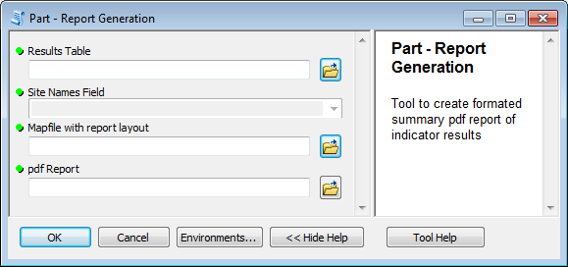

**Part – Report Generation**

The Report Generation tool uses the Results Table (Output from other tools) to create a PDF Report in the same way as the Full Tier 1 Assessment Tool, but the user is able to specify the Mapfile (.mxd) with the report layout in it. The user is also able to specify a field in the results table with names for the sites.

Heading for this? Is this a case example?

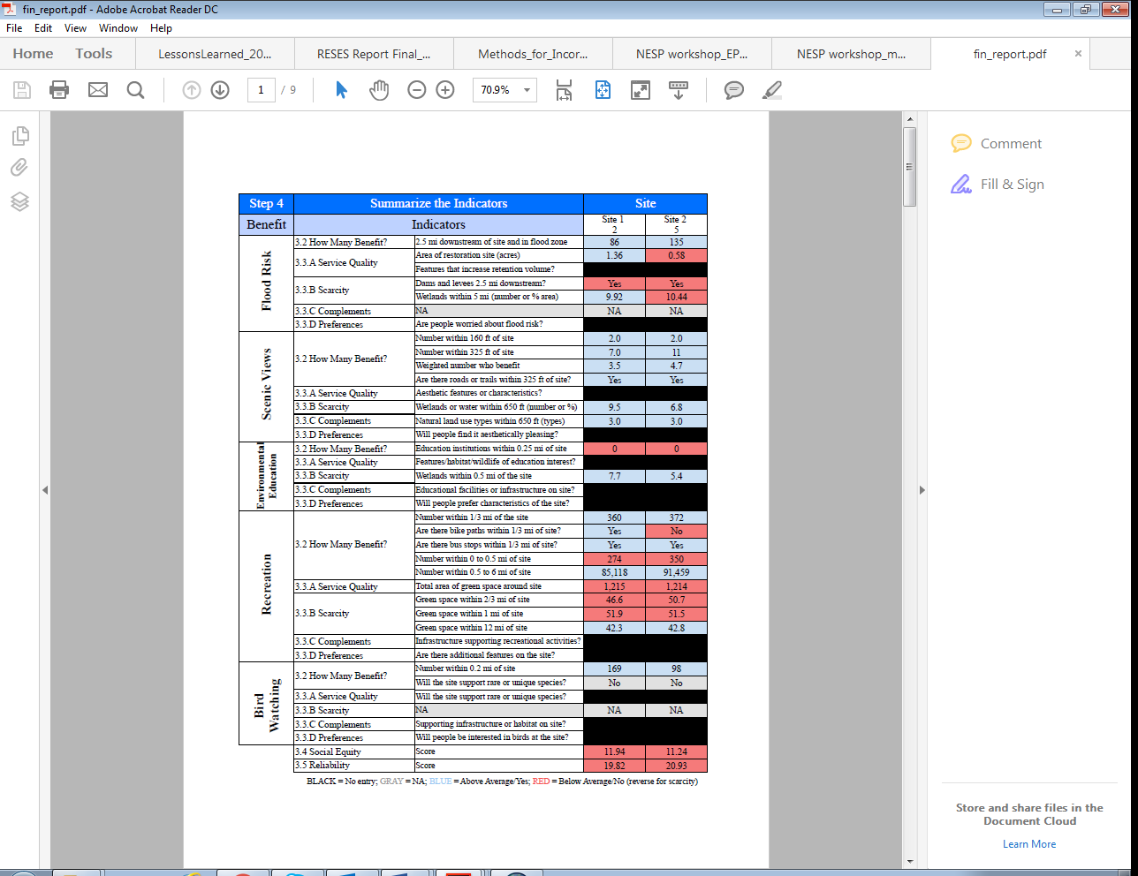

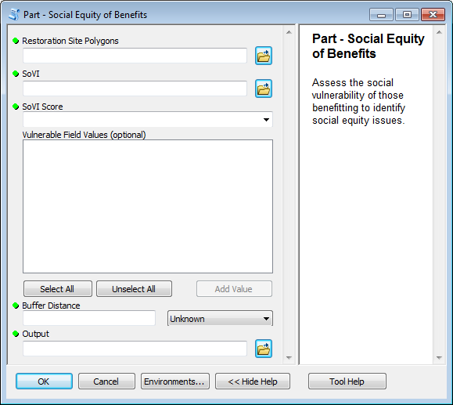**Part – Social Equity of Benefits**

The Social Equity of Benefits tool calculates the social equity of site benefits in the same way as the Full Tier 1 Assessment Tool, but the user is able to designate their own buffer distance around the restoration site that will be considered to determine the reliability instead of the default. The default the Full Tier 1 Assessment uses is the largest reasonable distance someone receiving one of the selected benefits could be from the site and still receive benefits [flood risk = 2.5 miles, recreation = 0.2 miles, bird watching = 100 meters, etc.].